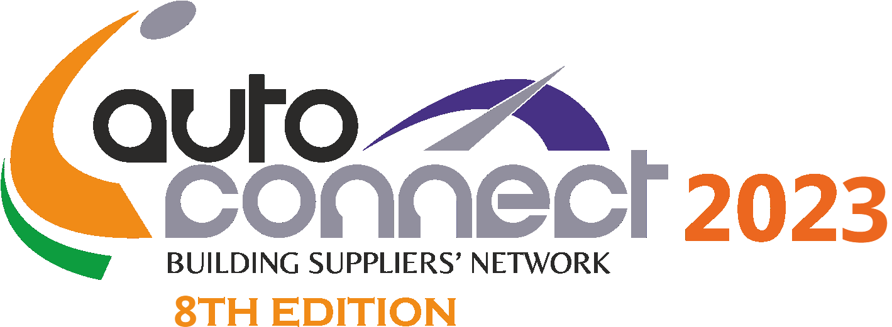

iAutoConnect 2023: ACMA Reverse Buyers - Sellers Meet
November 22 - 23, 2023, India International Convention and Exhibition Centre (ICC), Dwarka, New Delhi

Hosted Foreign Buyers Registration Form for attending

Thank you for applying as a Hosted Buyer at the forthcoming iAutoConnect 2023: ACMA Reverse Buyers -SellersMeet. Please note that mere submission of application does not guarantee your selection as a Hosted Buyer. Your application will be reviewed by the ACMA Screening Committee and all approved buyers shall be informed accordingly. The decision of the Screening Committee shall be final. Please enter correct information. ( Note: Only buyers with complete dose of vaccination are eligible for registering with iAutoConnect 2023)

You can submit the application form online at www.iautoconnect-acma.inor email a scanned copy to anjali.nair@acma.inorsudip.guharoy@acma.in

- Tell us about yourself and your company*:

Name of the applicant: __________________________________

Designation: ______________________________________

Name of Company / Organisation: ________________________________________________________________

Website: _________________________________ |  |  | Core Business Activity: ____________________
Address 1: ____________________________________________________________________________________

Address2: _______________________________ |  |  | City: ___________________________________
Country: ________________________________  Mobile: _________________________________ |  |  | Phone: _________________________________  Fax: ____________________________________  Passport Number: ________________________
Email: __________________________________

COVID-19 Vaccination:

1st Dose Date__________________

2nd Dose Date __________________

Name of Inoculant/Vaccine_________________

- Tell us about your business*:
Please attach your company’s financial statement (Balance Sheet) of last 3 years*:
Annual Business Turnover:  - 2017-18: ________ (in USD mln)  - 2018-19: ________ (in USD mln)  - 2019-20: ________ (in USD mln)  Current number of employees: ____________________  Vehicle Category of your business: 2 wheeler 4 wheeler |  | What was your Import value in 2020? ______ (in USD mln)  Present value of Import from India & Components imported? ___________________________________  What are your Major Import Products? _____________  ______________________________________________  Heavy Vehicles Heavy Commercial Vehicles
- Nature of Business:
OEM Automobile Manufacturer | Auto Component Manufacturer |  |  | Auto Component Distributor
Auto Component Importer | Agent / Representative |  |  | Government / Association
Others | Please specify:
- Products of your interest* (please tick):

Engine Components | Drive Transmission & Steering
Pistons | Crown Wheel Pinion | Master Cylinder Repair kit
Piston Rings | Clutch Plate & Assembly | Shock Absorbers
Cylinder Liners | Brake Pads/Lining/Shoe | Struts
Engine Gaskets | Power Steering Universal Joint | Wheel Cylinder Repair Kit
Engine Bearing | Drive Axle Shaft | Cooling Systems
Engine Valves | Drive Shaft Slip Yoke | Viscous Fan Assembly
Crank shaft | Spider Kit | Radiators
Chain sprocket | UJ Cross | Water & oil pump
Connecting Rods | Ball Suspension Joints | Electronics
Cylinder heads | Control Arm | Telematics
Tappets | Suspension & Braking | Sensors
Spark plugs | Leaf Spring | Navigation systems
Electricals | Consumables & Misc. | Injection Systems
Starter | Rear view mirrors | Diesel Pump Spares
Alternator | Filters (Oil, Air, Fuel, Cabin) | Gasoline Injection Spares
Lights / lamps | Locks | High Pressure Pipes
Switches | Wheel Bearing | Feed Pumps  Lubricants
Horns | Wiper Blades
Armature | Bulbs
Ignition coils
Batteries

Rubber Components
Hose | Exhaust rubber mounts
Engine mountings | Extruded rubber - Profiles
Strut mountings | Control arm bushes
Transmission mountings | Oil seals
Molded rubber parts  Tyre and Tubes  Any other Please specify_______________________  - The List is illustrative | Mechanical Control Cables

- Your key reason for attending iAutoConnect 2023*:

To evaluate products & technologies |  |  | To get technologies
To seek joint ventures & collaborations |  |  | To buy products
- Are you doing business with India*? Please elaborate on current activities:
__________________________________________________________________________________________________

__________________________________________________________________________________________________

- Any Comments you may wish to make:

_______________________________________________________________________________________________

- DOCUMENTS to be attached along with the reply form*:-

- Passport Size Photograph
- Passport Copy

The above documents are required for our records.

- Language Preference at the event: Spanish FrenchRussian English

- Fields marked with * are mandatory

I hereby submit my application. I am aware that mere application does not guarantee my selection as a Hosted Buyer. My application will be reviewed by the ACMA Screening Committee and I will be informed if I am selected as a Hosted Buyer.

Signature:_________________________________ Date:____________________________

